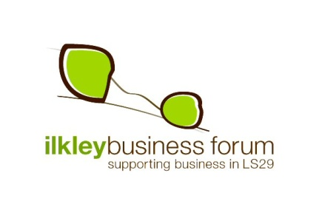
Welcome to the Ilkley Business Forum

Hello and a very warm welcome to Ilkley Business Forum (IBF)

Formed as a “not-for-profit” organisation in June 2009, IBF exists to:

- Promote and support businesses within the LS29 area
- Increase business transactions between its members
- Represent the interest of local businesses at a local and regional level
- Contribute to the prosperity of the LS29 community

This is achieved through:
- Monthly networking meetings
- Regular events which bring businesses, experts and academics together
- Raising the profile of LS29 businesses
- Influencing policy at a local level

Some benefits of being a member include:

- Increasing new business opportunities
- Free monthly business networking sessions
- Guest speakers on relevant business topics present at monthly meetings
- The opportunity to present your own business
- Free listing of business details on IBF website directory www.ilkleybusinessforum.co.uk
- Priority reservation to exhibit at IBF events such as the Showcase – local trade fair
- Being part of local business community acknowledged by Bradford Met & Ilkley Parish Council as representing the views and opinions of businesses in LS29
- Free participation in IBF sponsored “shop local” schemes
- Link to Burley Chamber of Trade
- Being part of a friendly, supportive and active network
- Your business will appear in the Members area of the IBF website – members are encouraged to do business with one another and so look to the members area when needing local business services and contacts.

Annual membership is £65 for the period 1st April 2015 to 31st March 2016

Please complete the form below and email it to Liz Scott, our membership coordinator, at liz.scott@lifeandlegal.com

Julia Forrester, our IBF treasurer will send you an invoice which you can pay online or by cheque.
Cheques are made payable to Ilkley Business Forum and any pro-rata payment is based on £5 per month plus £5 applicable for periods of less than twelve months to 31st March 2014.

I would like to take this opportunity to welcome you to the Forum

Steve

Steve Butler
Chair
Your personal details
First Name:
Surname:
Telephone number:
Mobile:
Job Title:
Details that will go on the IBF website
Name of Business:
Business address:
Website address:
Telephone / contact number:
Contact name and email address (only if you wish to make these public):
Business sector Please highlight the sectors in which your business operates within
Accommodation (B&B, Hotel, Self catering) | Florists | Motoring Service and Repair | Shop (retail) - stationary, books, office, art supplies…
Banks & Building Societies | Furniture | Photography | Shop (retail) – cake, coffee, sandwich…
Business Support Services | Gym, sports centre | Printing Services | Telecommunications
Complementary Therapies | Hairdressing & Beauty | Public Relations | Training &Development
Computing & Internet | Health professionals – physiotherapists, chiropractors, osteopaths, sports massage… | Professional services | Utilities
Dental Services | Homes (retirement, residential | Recruitment | Web design and web services
Educational services | Human resources | Restaurants & Pubs | Telecommunications
Electrical Retailers & Repair | Interior Design | Shop (retail ) – fashion, shoes, clothes… | Well being (fitness, massage, yoga…)
Estate Agents | Jewellers | Shop (retail ) – food, meat, fish… | Other (please state)
Financial services (accountants, book-keeping… | Legal Services and Solicitors | Shop (retail )- gifts | Other (please state)
1 line description of your business:
No more than 100 words to describe / promote your business:
Offers and discounts exclusive to IBF members:
Would you be happy for the IBF members’ database (our list which contains the names, organisations and contact details of all the members) to be shared with other IBF members □ Yes □ No
Please attach a .Jpeg Picture or logo for use on the website (max 300 pixels) Attached □ Yes □ No
Please return to Liz Scott via email at liz.scott@lifeandlegal.com

